System Overview + Architecture Diagram
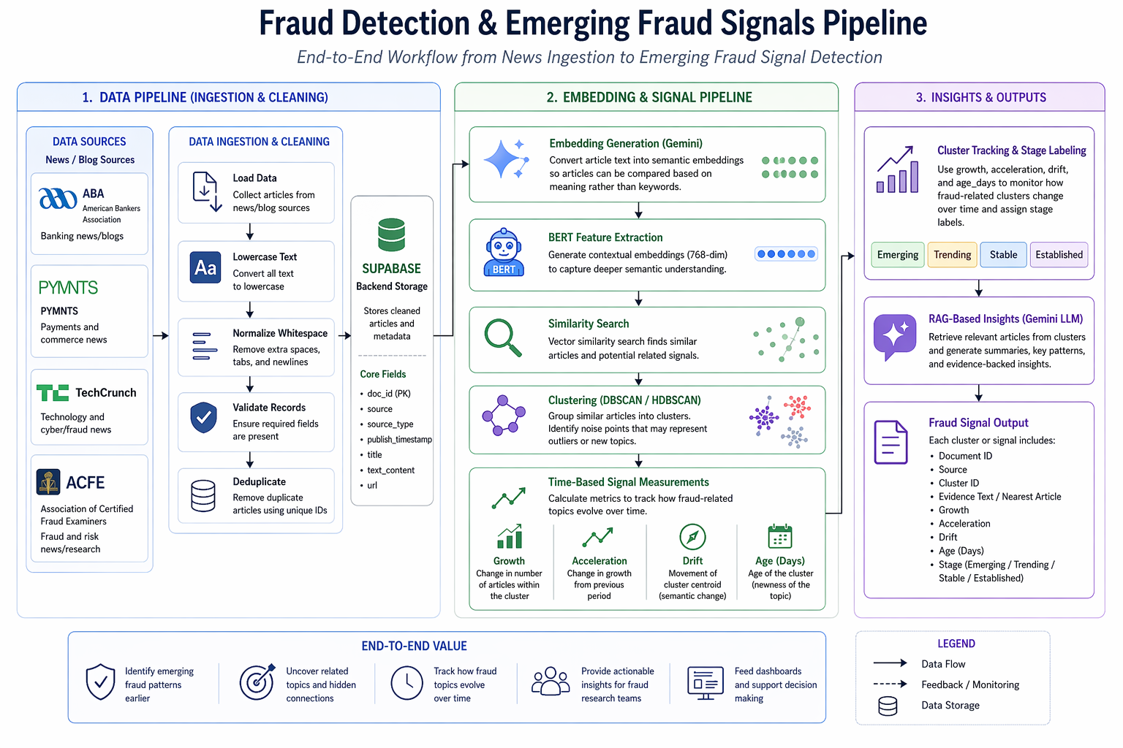

System Overview
The Emerging Fraud Signals Dashboard is a research-oriented fraud intelligence system designed to identify and monitor fraud-related patterns in public news and blog content. The system collects articles from selected external sources, cleans and stores the text, generates semantic representations, clusters related articles into fraud themes, and tracks how those themes evolve over time.
The system is intended to support fraud research, trend discovery, and analyst review rather than real-time transaction monitoring or automated fraud decisions.
At a high level, the architecture has three major layers:
- Data Pipeline
Collects and preprocesses article data from external news/blog sources.
- Embedding & Signal Pipeline
Converts article text into embeddings, groups similar articles, and computes temporal trend metrics.
- Insights & Output Layer
Produces cluster-level outputs, stage labels, and retrieval-based summaries for dashboard consumption and analyst use.

Main Components

1. External Data Sources
The system ingests public news and blog content from:
- ABA
- PYMNTS
- TechCrunch
- ACFE
These sources provide coverage across banking, payments, fraud, and technology-related reporting.

2. Data Ingestion & Cleaning Pipeline
This component is responsible for collecting raw article content and preparing it for downstream processing.
Core functions:
- load article data from source feeds
- convert text to lowercase
- normalize whitespace
- validate required fields
- remove duplicate records

3. Supabase Backend
Supabase serves as the central storage and retrieval layer for the project.
It stores:
- cleaned article records
- metadata such as source, title, publish timestamp, and URL
- generated embeddings
- cluster-level outputs and metrics
Supabase also supports read/write operations between the Python notebooks and the stored project data.

4. Embedding Generation
This component transforms cleaned article text into semantic vector representations using Google Gemini embeddings.
Purpose:
- allow similarity comparisons between articles
- support retrieval and clustering based on meaning rather than exact keywords

5. BERT Feature Extraction
BERT is used to create contextual embeddings that improve semantic grouping and downstream clustering.
Purpose:
- capture richer contextual meaning from article text
- support topic discovery among fraud-related articles

6. Similarity Search
Similarity search compares embeddings to identify articles that are semantically related.
Purpose:
- find related fraud signals
- support retrieval for investigation and cluster interpretation

7. Clustering Engine
DBSCAN/HDBSCAN is used to group similar articles into clusters and identify noise points or outliers.
Purpose:
- surface fraud-related topic groupings
- isolate potentially new or weakly connected signals

8. Time-Based Signal Measurement
This component calculates metrics used to monitor how a cluster changes over time, including:
- growth
- acceleration
- drift
- age_days
These measures help determine whether a fraud topic is emerging, trending, stable, or established.

9. Stage Labeling & Insights Layer
Cluster-level metrics are used to assign stage labels and support interpretability.
Outputs may include:
- cluster ID
- representative article / nearest article
- growth, acceleration, drift, age_days
- stage label
- retrieval-based summaries using Gemini

10. Dashboard / Analyst Consumption
The final outputs are intended for dashboard views and analyst workflows.
Use cases:
- explore emerging fraud topics
- review cluster evidence
- support proactive action and reporting

Data Flows
The system follows a sequential flow from ingestion to insight generation.

Step 1: Source Collection
Articles are collected from ABA, PYMNTS, TechCrunch, and ACFE.

Step 2: Cleaning and Validation
Raw article text is lightly cleaned by:
- converting to lowercase
- normalizing whitespace
Records are also validated and deduplicated.

Step 3: Storage in Supabase
Cleaned article records and metadata are stored in Supabase.

Step 4: Embedding Generation
Article text is converted into semantic embeddings.

Step 5: Contextual Feature Extraction
BERT embeddings are generated to strengthen semantic grouping.

Step 6: Similarity Search and Clustering
Embeddings are compared and clustered via DBSCAN to identify groups of related articles.

Step 7: Temporal Analysis
Cluster behavior is tracked over time using growth, acceleration, drift, and age_days.

Step 8: Stage Labeling and Summarization
Clusters are assigned stage labels, and representative evidence or summaries can be generated.

Step 9: Output to Dashboard / Research Layer
Final structured outputs are surfaced for dashboarding, monitoring, and analyst interpretation.

Dependencies
The system depends on several tools, libraries, and services.

Core Languages / Environment
- Python
- Jupyter Notebook

Python Libraries
- pandas
- numpy
- scikit-learn
- transformers
- sentence-transformer style embedding workflows / model APIs
- clustering and similarity libraries used with DBSCAN/HDBSCAN and cosine similarity

External Services
- Supabase for backend data storage and retrieval
- Google Gemini API for embedding generation
- Gemini LLM for RAG-style summarization and insight generation

Modeling / NLP Components
- Gemini embeddings
- BERT embeddings
- DBSCAN / HDBSCAN clustering
- similarity search
- time-based signal metrics

Environments
The system currently operates in a research / notebook-based environment rather than a production deployment.

Development Environment
- Jupyter notebooks used for ingestion, preprocessing, embedding generation, clustering, and analysis
- Python local or hosted notebook runtime

Storage Environment
- Supabase cloud backend used for persistent storage of articles, embeddings, and outputs

API Environment
- External API access for Gemini embedding and summarization steps

Target Output Environment
- dashboard / visualization layer for presenting fraud signals and supporting analyst workflows

Current State
This project is best described as a prototype or research environment, not a production-grade system. It emphasizes explainability and feasibility over automated deployment, streaming ingestion, or real-time orchestration.

Architecture Summary
The architecture is modular and flows from data collection to insight generation:
News/Blog Sources → Data Cleaning → Supabase Storage → Embedding Generation → BERT Feature Extraction → Similarity Search → Clustering → Time-Based Signal Metrics → Stage Labeling / RAG Insights → Dashboard Outputs
This design makes the system easier to explain, audit, and extend. Each component has a defined role, and the Supabase backend acts as the shared data layer connecting ingestion, modeling, and output generation.

